Historical Investigation
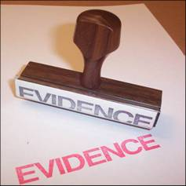

History Internal Assessment

Student Guide

Franklin High School, IB

Table of Contents for Diploma History HI Handbook

Focus Page Number

Front Page

Table of Contents ii

Outline of the Historical Investigation 1-3

Advice on your Historical Investigation Topic 4-6

Historical Investigation Ideas Sheet 7

Historical Investigation Source Ideas Sheet 8

An Example of Narrowing Down a Topic 9

Guidance on How to Structure an HI Question 10-12

Historical Investigation Proposal Form 13

A Research Notes Template Example 14

A Research Diary Example 15

Summary of Evidence Planning Table Example 16

Summary of Evidence Planning Table Template 17

First Draft Template for the Historical Investigation 18-19

Final Draft Checklist for the Historical Investigation 20

APPENDIX A: Assessment Criteria from 21-23
IB DP History Subject Guide

Historical Investigation
HL 20% SL 25%
Introduction

The historical investigation is a problem-solving activity, which enables candidates to demonstrate the application of their skills and knowledge to an area, which interests them. The emphasis must be on a specific historical inquiry tied to classroom activities that enables the candidate to develop and apply the skills of a historian, such as making sense of source material and managing conflicting interpretations. The internal assessment allows for flexibility; the assignment should encourage candidates to use their own initiative.

The activity demands that candidates search for, select, evaluate, and use evidence to reach a decision or solve a problem. The investigation is not major pieces of research–candidates are only required to evaluate two of the sources they have used. However, these must be appropriate to the investigation and critically evaluated. The account is not written as an essay, but in the style outlined later in this section.

Objective: Students will conduct a historical investigation in relation to 20thcentury World History. This investigation will further develop their research skills and prepare them for the Internal Assessment component of the Diploma Program.

During the Diploma Program, students will be required to conduct an independent investigation regarding a historical topic of their choice. The investigation is designed to demonstrate research skills, evaluation, and analysis skills in multiple ways as a cumulative project.

Assignment:
- Students will investigate a Historical topic based the course syllabus.
- Students will produce a written account of their historical investigation between 1500-2000 words.
- The investigation will be assessed for content and organization.
- The investigation is broken into six segments: (taken from the IB Diploma Program paperwork)

- Plan of the investigation (100-200 words):
Objective: Knowledge and Understanding
Demonstrate knowledge and understanding of a specific historical topic. State the topic of the investigation in the form of a question. Define the scope of the investigation and explain the method of the investigation.

Plan of the investigation

The plan of the investigation must include:

- the subject of the investigation, written as a question
- an explanation of the relevance and significance of the topic
- identification of the scope of the investigation
- the methods to be used in the investigation, including identification of the two main sources to be evaluated.
- Identification of the organization to be used in the investigation.
- Summary of Evidence(500-600 words):
Objective: Application, Interpretation, and Use of Historical Skills
Present a summary of evidence and demonstrate evidence of research skills, organization, and referencing. Summarize the information discovered in the investigation drawing from sources that are appropriate to the investigation. Appropriately presenting and documenting the information.

Summary of evidence includes:

- The summary of evidence should indicate what the candidate has found out from the sources he or she has used.
- It must be in the form of a list with bullets.
- Each fact submitted must be cited. Any illustrations, documents, or other relevant evidence should be included in an appendix and will not be included in the word count.

- Evaluation of Sources (300-400 words):
Objective: Synthesis and Evaluation
Evaluate historical sources as evidence and show understanding of OPVL by critically evaluating two important sources appropriate to the investigation.

Evaluation of sources:

- This section of the written account is a critical evaluation of two important sources appropriate to the investigation. Only two sources are evaluated; however, more sources are required for the investigation.
- Each evaluation must refer to their origin, purpose, value, and limitation.
- The evaluation must explain how the source develops the historiography of the investigation.
- This section is presented in two paragraphs; one paragraph per source.

- Analysis (500-600 words):
Objective: Synthesis and Evaluation
Write an analysis that breaks down complex issues in order to bring out the essential elements, any underlying assumptions, and any interrelationship involved. Demonstrate an understanding of the issue in its historical context. Offer a critical examination of the factual materials presented and demonstrate an awareness of the significance of sources used acknowledging different interpretations of evidence, where appropriate.

Analysis includes:
- the importance of the investigation in its historical context
- analysis of the evidence presented as a debate/historiography
- if appropriate, different interpretations

- Conclusion (100-200 words):
Objective: Synthesis and Evaluation
Concisely finalize the paper with a response to the original research question that is clearly stated. Synthesize any final analysis that is consistent with evidence presented and relevant to the research question.

Conclusion must:
- Answer the question presented in the plan of investigation
- Be clearly stated and consistent with the evidence presented.

- Sources and formatting:
Objective: Use of Historical Skills
Demonstrate evidence of research skills, organization and referencing. A bibliography must be included. Formatting and documentation, using one standard method (Turabian) must be included. None of these will form part of the word count. The word count for the investigation must be clearly and accurately stated on the title page. All margins and additional paper requirements must be appropriate.

The Written Account Total: 1500–2000 words 25 marks

Regardless of the type of historical investigation chosen, every candidate must produce a written account consisting of the following six sections:

A | Plan of the investigation | 3 marks
B | Summary of evidence | 6 marks
C | Evaluation of sources | 5 marks
D | Analysis | 6 marks
E | Conclusion | 2 marks
F | List of sources | 3 marks
Total |  | 25 marks

Choice of Topic

Candidates should choose their own topic, with the teacher’s guidance.

- The topic should be one that seems interesting and worthwhile to the candidate.
- The topic must fall within the syllabus topics covered in HL 1 or HL 2.
- The teacher must approve the investigation before work begins: student must ensure that it complies with the regulations and is able to be assessed by the criteria for internal assessment.

Candidates must be aware of ethical considerations when undertaking any investigation. They must show tact and sensitivity, respect confidentiality and acknowledge all sources used.

Advice on your Historical Investigation Topic

Below are some points that you need to think about in relation to your topic for the Historical Investigation:

Topic

Possible Topics for a Historical Investigation

Historical investigations explore a topic drawn from our syllabus to develop a deeper understanding of a topic that may appear on the May exams. It is highly recommended that you select an area to focus on that you already have some background knowledge and a deep interest in learning.

The selection of a topic should take into account the amount of material available and the scope for personal and individual investigation. Before submitting a research question, make sure there are available resources.

Look for topics that are unique and original. Avoid topics that are common and overdone. Avoid papers that are vague or cover a broad idea. These papers tend to be marked poorly.
Ex: The Hitler, WWII, and the Holocaust have been written about ad nauseum. Choose something unique (person, event, or policy) or choose a different topic.

Do not procrastinate. This is an involved project that requires time; planning, research, creating, and editing. Rushed papers result in very low marks. Discipline yourself, meet your deadlines, and give yourself plenty of time for revising.

Do not rely solely on the internet; look for books, magazines, and newspaper articles at the local library. Papers that are marked high usually utilize a variety of media.

Take time to visit during lunch or after school to examine past HI papers, including marks and comments, in order to best understand the demands of the assignment.

Structure and Topic development:

In parts of your Historical Investigation, you will need to analyze and evaluate at least two different historical points of view. You are creating a debate or discussion on paper and therefore should have more than one potential answer to the research question.

To help you achieve this, the topic of the Historical Investigation must be phrased as a question that can be evaluated and analyzed. In structuring such a question, you should consider the phrases “did,” “to what extent,” or “how far.”

“What” and “how” questions should be avoided because they foster a descriptive or narrative approach.

For example, a good question would be:

- To what extent did Hitler’s foreign policies lead to war in 1939?
- To what extent did “appeasement policies” lead to war in 1939?
- Did women’s participation in WWI influence the passage of the 19th Amendment?
- Did President Andrew Johnson deserve to be impeached?
- In what ways did the Triangle Shirtwaist Factory Fire lead to improved work safety conditions in the United States?
- How do the earlier interpretations of jihad during the Medinan period of the Prophet Muhammad’s life differ from modern interpretations of the term as used by radical Islamic militant groups?
- How did the Women’s Coastguard Reserves of World War II change the role of women in the US military?
- To what extent did the cooperation between the Allied and the Mafia during the Allied invasion of Sicily in the Second World War contribute to the re-establishment of Mafia control in Sicily, after Mussolini’s attempt to reduce them?
- Afghanistan and the United States connection: To what extent did the anti-communist policies of the United States contribute to the rise of the Taliban?

A poorly phrased question for a Historical Investigation would be:

- What was Hitler’s foreign policy between 1933 and 1939?
- Who caused WWII?
- How did Sputnik influence the Space Race?
- What was the result of the Cuban Missile Crisis?

These topics result in a narrative paper that simply regurgitates research. There is minimal analysis opportunities and very little historiography.

You must also structure your Historical Investigation according to the structure laid out on page 4. You should also read carefully the assessment criteria given in Appendix A at the back of this booklet.

Personal Interest

The Historical Investigation must be on a historical topic or issue that you are interested to find out more about. Your teacher will advise you and act as your tutor, but ultimately the effort, dedication, and inspiration must come from you. This is why the choice of topic and the question is fundamentally crucial to a good Historical Investigation. Remember to keep in mind that a well-produced Historical Investigation will set you up with a strong grade before you do your final examinations in May.
Here are a few places to look for ideas for research questions.

- Your syllabus and class notes: What did you find interesting? Start here.

- International School of Toulouse Gallery of Past Investigations

http://www.internationalschooltoulouse.net/ibhistory/coursework/internal_assessment/index.htm

- Casahistoria is a great website that is tailored for students of history that might also be a good place to find research. http://www.casahistoria.net/

- History Channel at History.com

- Explore Google to see what research sources and ideas are out there. What information can you access?

- Be aware when searching the internet. Not all recommended topics out there actually make a good paper. Many “recommended topics” from student developed sites such as IB Survival and Suite 101 are poorly written, do not develop proper historiographies, and have been done many times. These papers will earn low marks.

Historical Investigation First Thoughts Sheet

Fill in this sheet to help you start thinking about your historical investigation. Think carefully about your answers:

Circle the option for you:

- Which period of History interests you mainly?

Early American History American Civil War American Reconstruction

1900’s Pre WWI WWI Interwar Years 1920-1939

WWII Cold War Civil Rights

20th Century Single Party States Mexican Revolution

3) What sort of History are you interested in?

Political Economic Social Military

4) Which subtopics of History do you want to explore?

Battles Technology Minority rights Laws

Policies Treaties Other: _________________________

5) Make a list of individual people or events you want to learn more about:

6) Write down a list of possible areas of interest:

Historical Investigation Source Ideas Sheet

The most important part of your historical investigation is finding two sources that provide conflicting interpretations of the same event. These do not always have to be in the form of history books. They can be works of literature, personal diaries, detailed posters, and even films. Look at the examples below that you could use to help in your historical investigation e.g.

Literature:
George Orwell – “Animal Farm” (Russia 1917-1945)
Harper Lee – To Kill a Mockingbird (Racial discrimination in the United States)
George Orwell – “The Road to Wigan Pier” (Britain in the 1930’s)
Erich Maria Remarque – “All Quiet on the Western Front” (World War One)
George Orwell – “1984” (Totalitarian regimes)
Jung Chang – “Wild Swans” (20th Century China)
William Shakespeare – “Julius Caesar” (Roman Empire)
E.M.Forster – “A Passage to India” (British India between WW1 and WW2)

Film:

JFK – Murder of John F Kennedy
Thirteen Days – Cuban Missile Crisis
Saving Private Ryan – D-Day Landings
Schindlers List – Holocaust (there are now many films and memoirs available on this topic)
Apocalyse Now – Vietnam (There are many on this conflict)

Speeches:

“Give Me liberty or Give Me Death” by Patrick Henry
“Gettysburg Address” by Abraham Lincoln
“I Have a Dream” by Dr. Martin Luther King, Jr.
“I’ve Been to the Mountaintop” speech by Dr. Martin Luther King, Jr.
“The Ballot or the Bullet” Speech by Malcolm X
“D-Day Invasion” Speech to Soldiers by General Eisenhower
“We Shall Fight on the Beaches” speech by Winston Churchill
“Speech on Women’s Rights to Vote” by Susan B. Anthony
“Inauguration Address” by John F. Kennedy, 1961

You could compare each of these sources to a more standard historical book on an issue in the work of fiction or feature film.

You may be better able to think of some a topic from your personal heritage/national history you may want to do. Be aware though of the importance or accessing the necessary sources.
An Example of Narrowing Down a Topic
Taken from http://www.historyguide.org/guide/image.html

“You also need to look at your topic realistically. Obviously, no one would contemplate a topic as broad as “A History of Europe, 1648-1996,” for an essay only twenty pages in length. Not only could you not condense 350 years of European history in twenty pages, fifteen weeks is hardly enough time to do the research for a longer study, even if it were possible.

If you know very little about your topic, your first task is obviously to learn more. Suppose your general topic is the Age of Enlightenment. This is a broad topic. Consult an encyclopedia. You will run across names (Diderot, Rousseau, Voltaire, Paine), events (Lisbon Earthquake, French Revolution), and ideas (skepticism, deism, liberty). Perhaps one of these things grabs your attention. Suddenly, you find yourself attracted to Tom Paine’s essay The Age of Reason, in general, and his ideas on deism in particular. You begin to ask yourself questions: who was Tom Paine? What is deism? Who were the deists? Why did deism appear when it did? What effect does deism have on the movement for parliamentary reform in England in the 1790s? Then, for whatever reason, you are led to an entirely different topic, say, English political radicals in the age of the French Revolution.

Through your discovery of Paine’s Rights of Man, you encounter the radical philosopher William Godwin. He was an anarchist, which is odd because he was writing at a time (1790s) when most English radicals were trying to reform Parliament, not abolish it altogether. You then thumb through a brief biography of Godwin and soon discover that he married Mary Wollstonecraft, an out-spoken feminist who wrote the first critique of Edmund Burke’s Reflections on the Revolution in France (Paine’s Rights of Man was a response to Burke’s Reflections as well). You also find out that Godwin and Wollstonecraft produced a daughter, Mary, who later married Percy Bysshe Shelley, and wrote Frankenstein. Quite a jump from your first initial interest in Paine’s deism, isn’t it? In addition, all of this could have taken place in a week or two. I mention this example because using this same technique; I arrived at a topic for seminar paper which happened to be about the notion of human perfectibility in the thought of William Godwin.”
Guidance on How to Structure an HI Question
Adapted from Historians’ Fallacies by David Fischer

An essential skill of the historian is the ability to ask questions. While this may seem like an easy task, it may in fact be one of the most difficult. A historian is someone who asks an open-ended question about past events and answers it with selected evidence that is arranged in an explanatory way. “Questions are the engines of intellect … which convert energy to motion, and curiosity to controlled inquiry.” (3)

There are five general characteristics that a good historical question should have:

- It must be resolvable with measurable (empirical) evidence

- It must be open-ended

- It must be flexible and open to endless refinement

- It must be explicit and precise

- It must be tested

The following assignment will try to identify some of the common problems in asking historical questions.

Types of problems:

- Too large of a scope:

- Who won the American Civil War?
- What happened during World War 1?
- Who won the Cold War?

The problem with this question is that it is so broad and that there is so much information on the question that it becomes impossible to answer correctly. In order to have a proper focus one needs to start with a reverse pyramid approach to questioning.
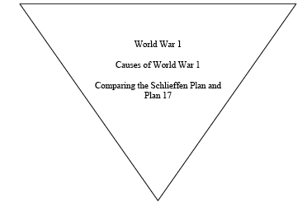
2. Non-question that sets out to prove an existing opinion

The historian cannot prove something s/he has already concluded to be true. If you begin your inquiry with the conclusion that “X was the case” than you will simply be trying to find evidence to support your case not trying to discover historical truth. This can also happen by limiting the sources that you choose to gather your evidence. If you try to answer your question by only looking at sources from one perspective, your question will not be answered in a balanced way.

3. Too many questions

This problem involves framing a question that makes false presumptions.

- A historical example is “What were the US’ primary motives for dealing with Hussein”

- Another example is

“Why are all radical revolutions violent?”
“Why did the United States win the Cold War?”
“How did Hitler ignite WWII?”

This assumes that these questions are true before research begins.

4. A question that demands a choice between two answers, which are in fact not exclusive or not exhaustive.

This type of question assumes that there is no choice between two opposites. It is also called either or thinking. It assumes that there are no other options or that there is no middle ground between the two positions.

For example, questions like:

“The Fall of the Russian Monarchy- Inherent Failure or Planned Revolution?” assumes only two options are available. It also assumes that there is somehow a relationship between the two ideas and that both ideas are mutually exclusive.

5. The abstract or metaphysical question

This is the failure in which a non-empirical problem tries to be solved by empirical means.

For example “Why was Lincoln shot?”
“Was the Korean War inevitable?”

When posing a why question, the historian must be careful to define what s/he is trying to determine. Is the “why” to determine the motive, reason, is a description of possibilities, a historical process, the purpose behind the action, or a justification. Why questions on their own lack direction, clarity and need to be carefully thought through.

- What if questions

This is where the historian attempts to explain through empirical evidence what might have happened in history, if in fact it actually had. While what if questions are very interesting and can serve to help clarify historical events they ultimately prove nothing and cannot be viewed as the same as historical evidence.

For example, what would have happened if the Nazi’s had developed the atomic bomb first?

All historical evidence for what might have happened is necessarily taken from the world in which the Nazi’s did not develop the bomb first. There is no way to escape this fundamental fact, therefore any records or evidence used are immediately counterfactual.

Avoid conspiracy theory or suppositional topics that cannot be answered with any authority. These include topics on “alternate history” or topics that do not have valid research material available.

For example:

- How did Freemasons affect the early development of the United States? (You won’t find information about the Freemasons.
- Who assassinated President John F. Kennedy?
- Did aliens land in Area 51?
- Was the 9/11 attack a US Government cover up?

History Investigation Proposal Form

Topic/Question

Justification about why I want to study this Topic/Question

A list of five sources (fully referenced) that I have found already and will prove useful.

Two sources that I could use for Section C. Justification for why I think they are useful for Section C.

The below sheet is a suggestion of a format for your research journal. You will each be expected to keep a clear record of each source that you consult in your research diary and have a research page where you take notes. You will be checked periodically. (read: LIVE IN FEAR!!! ☺)
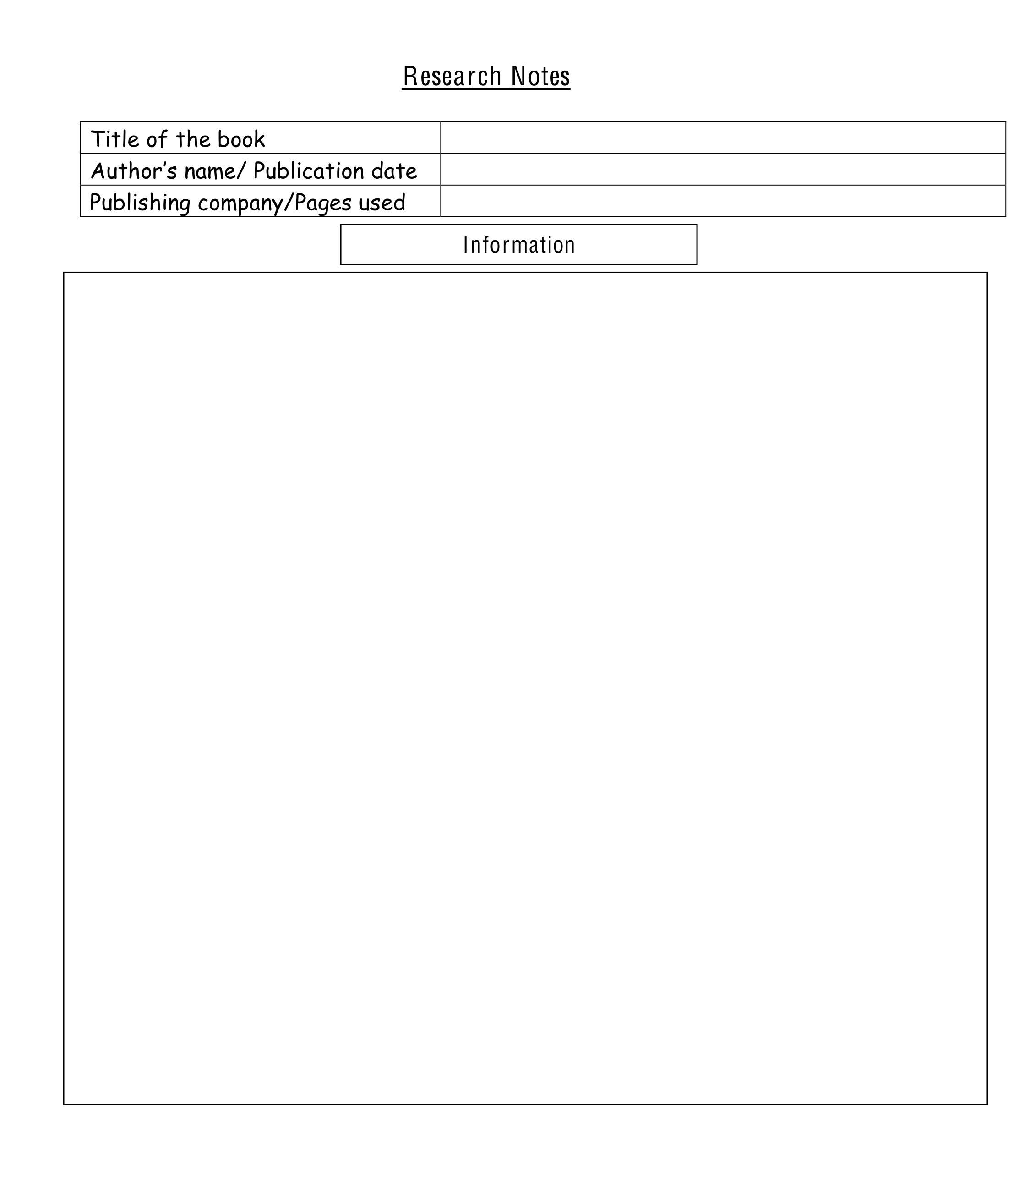
Research Diary Template

Date | Time Spent | Median of Research | What did you learn from this source? | Where are you going to go next?

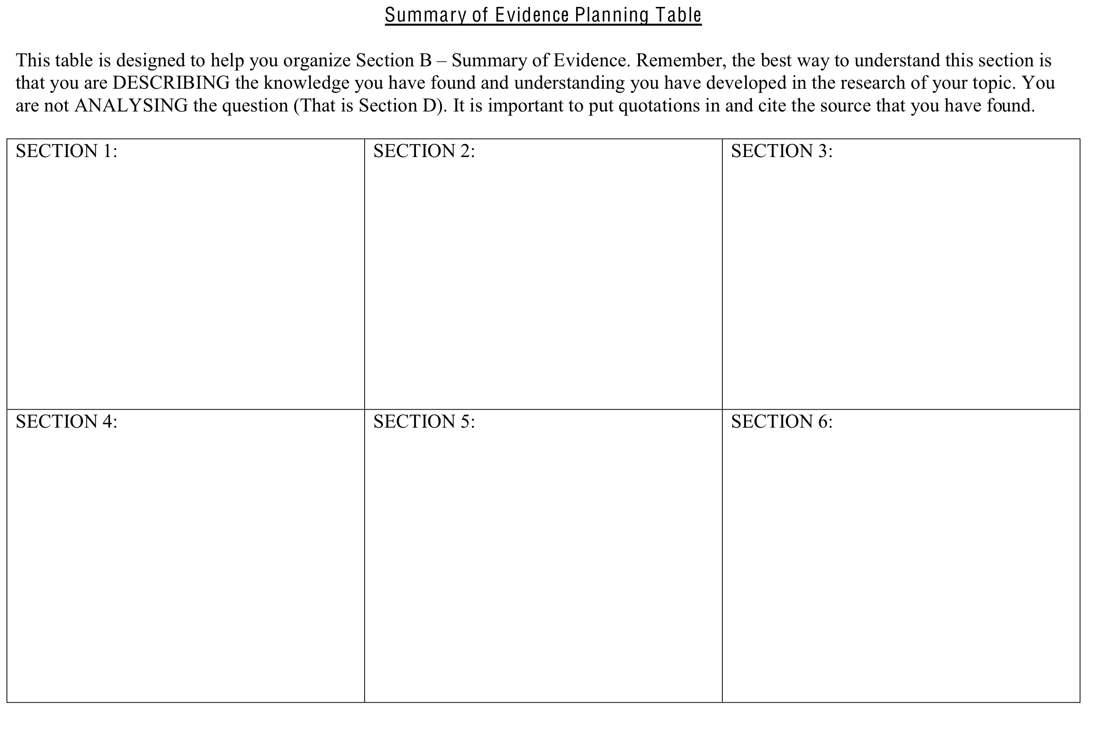

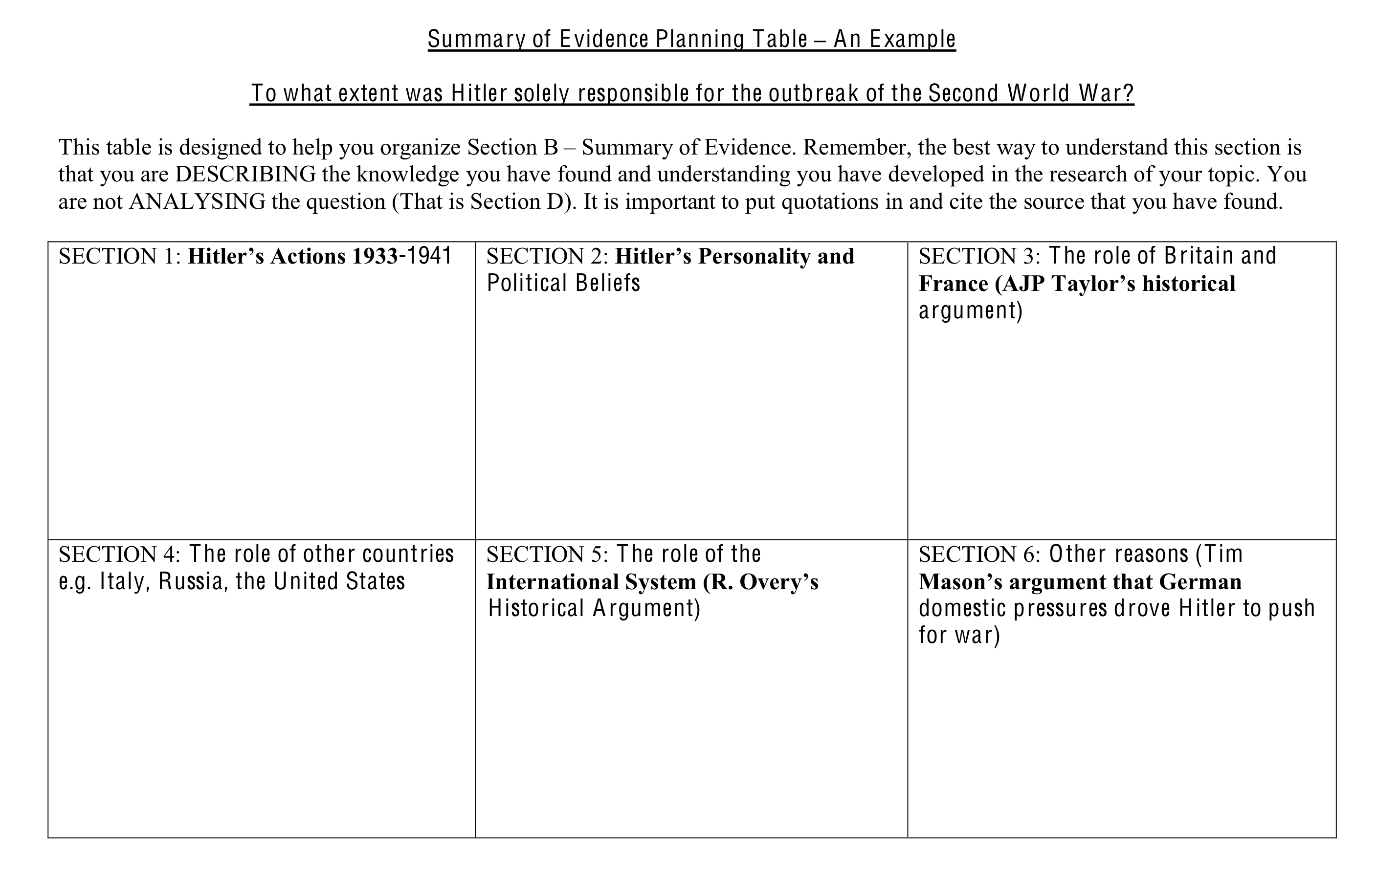

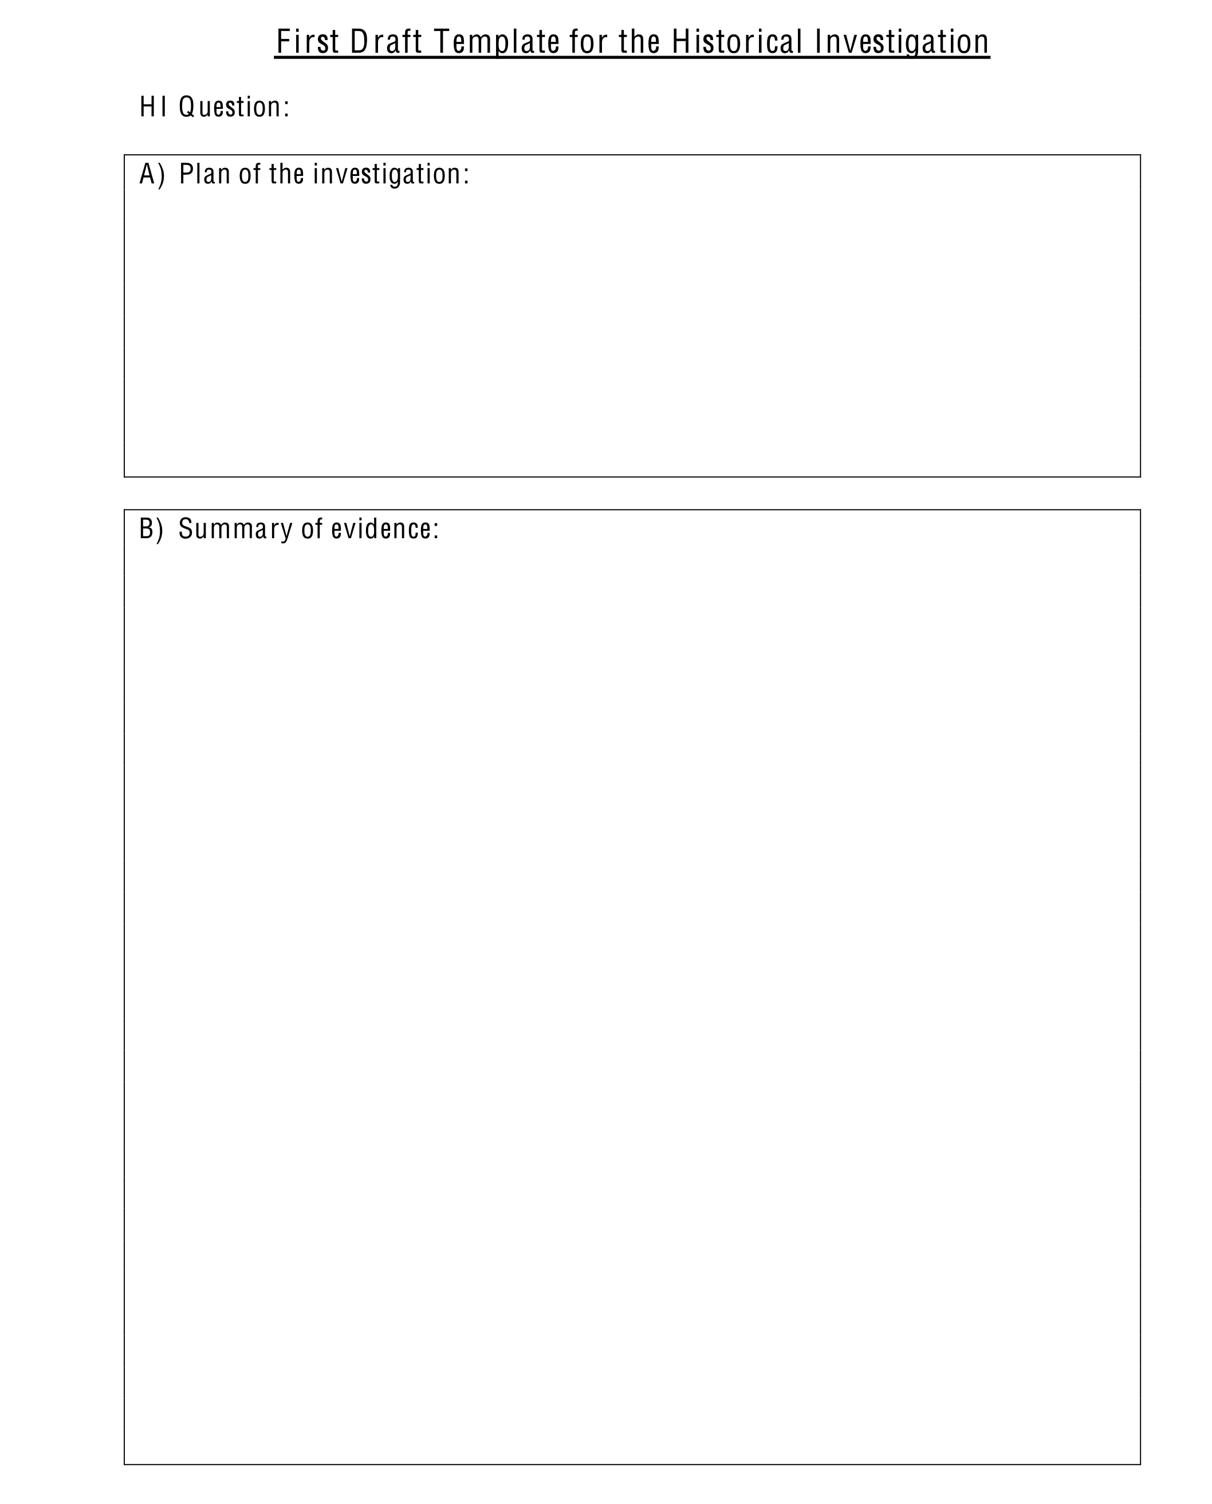

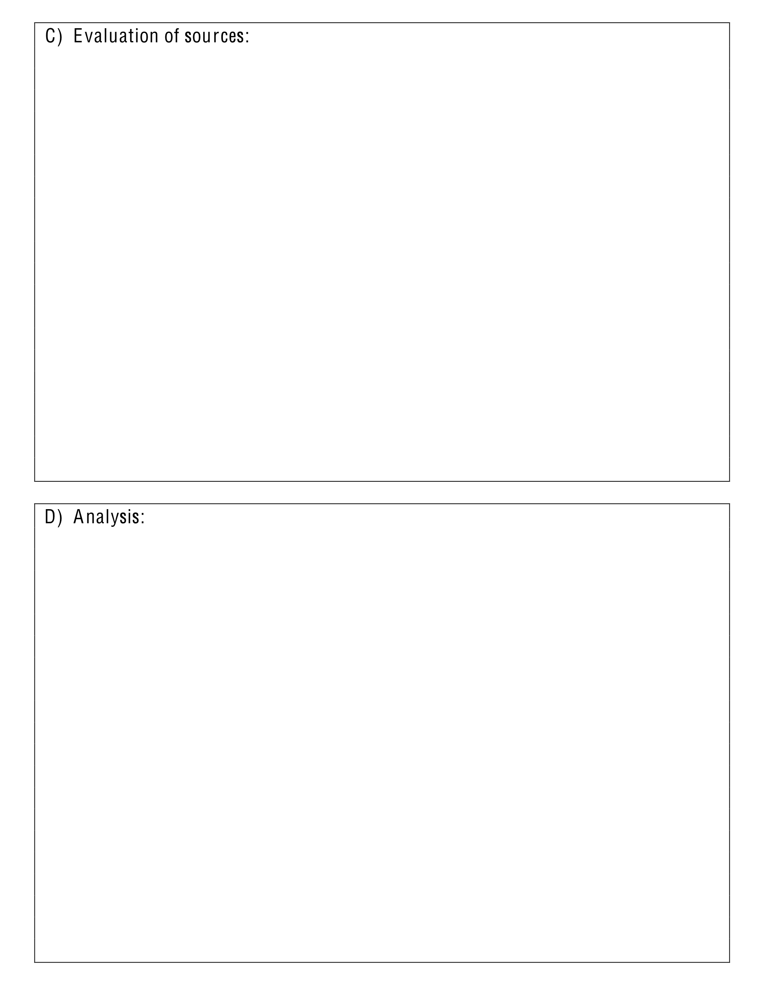
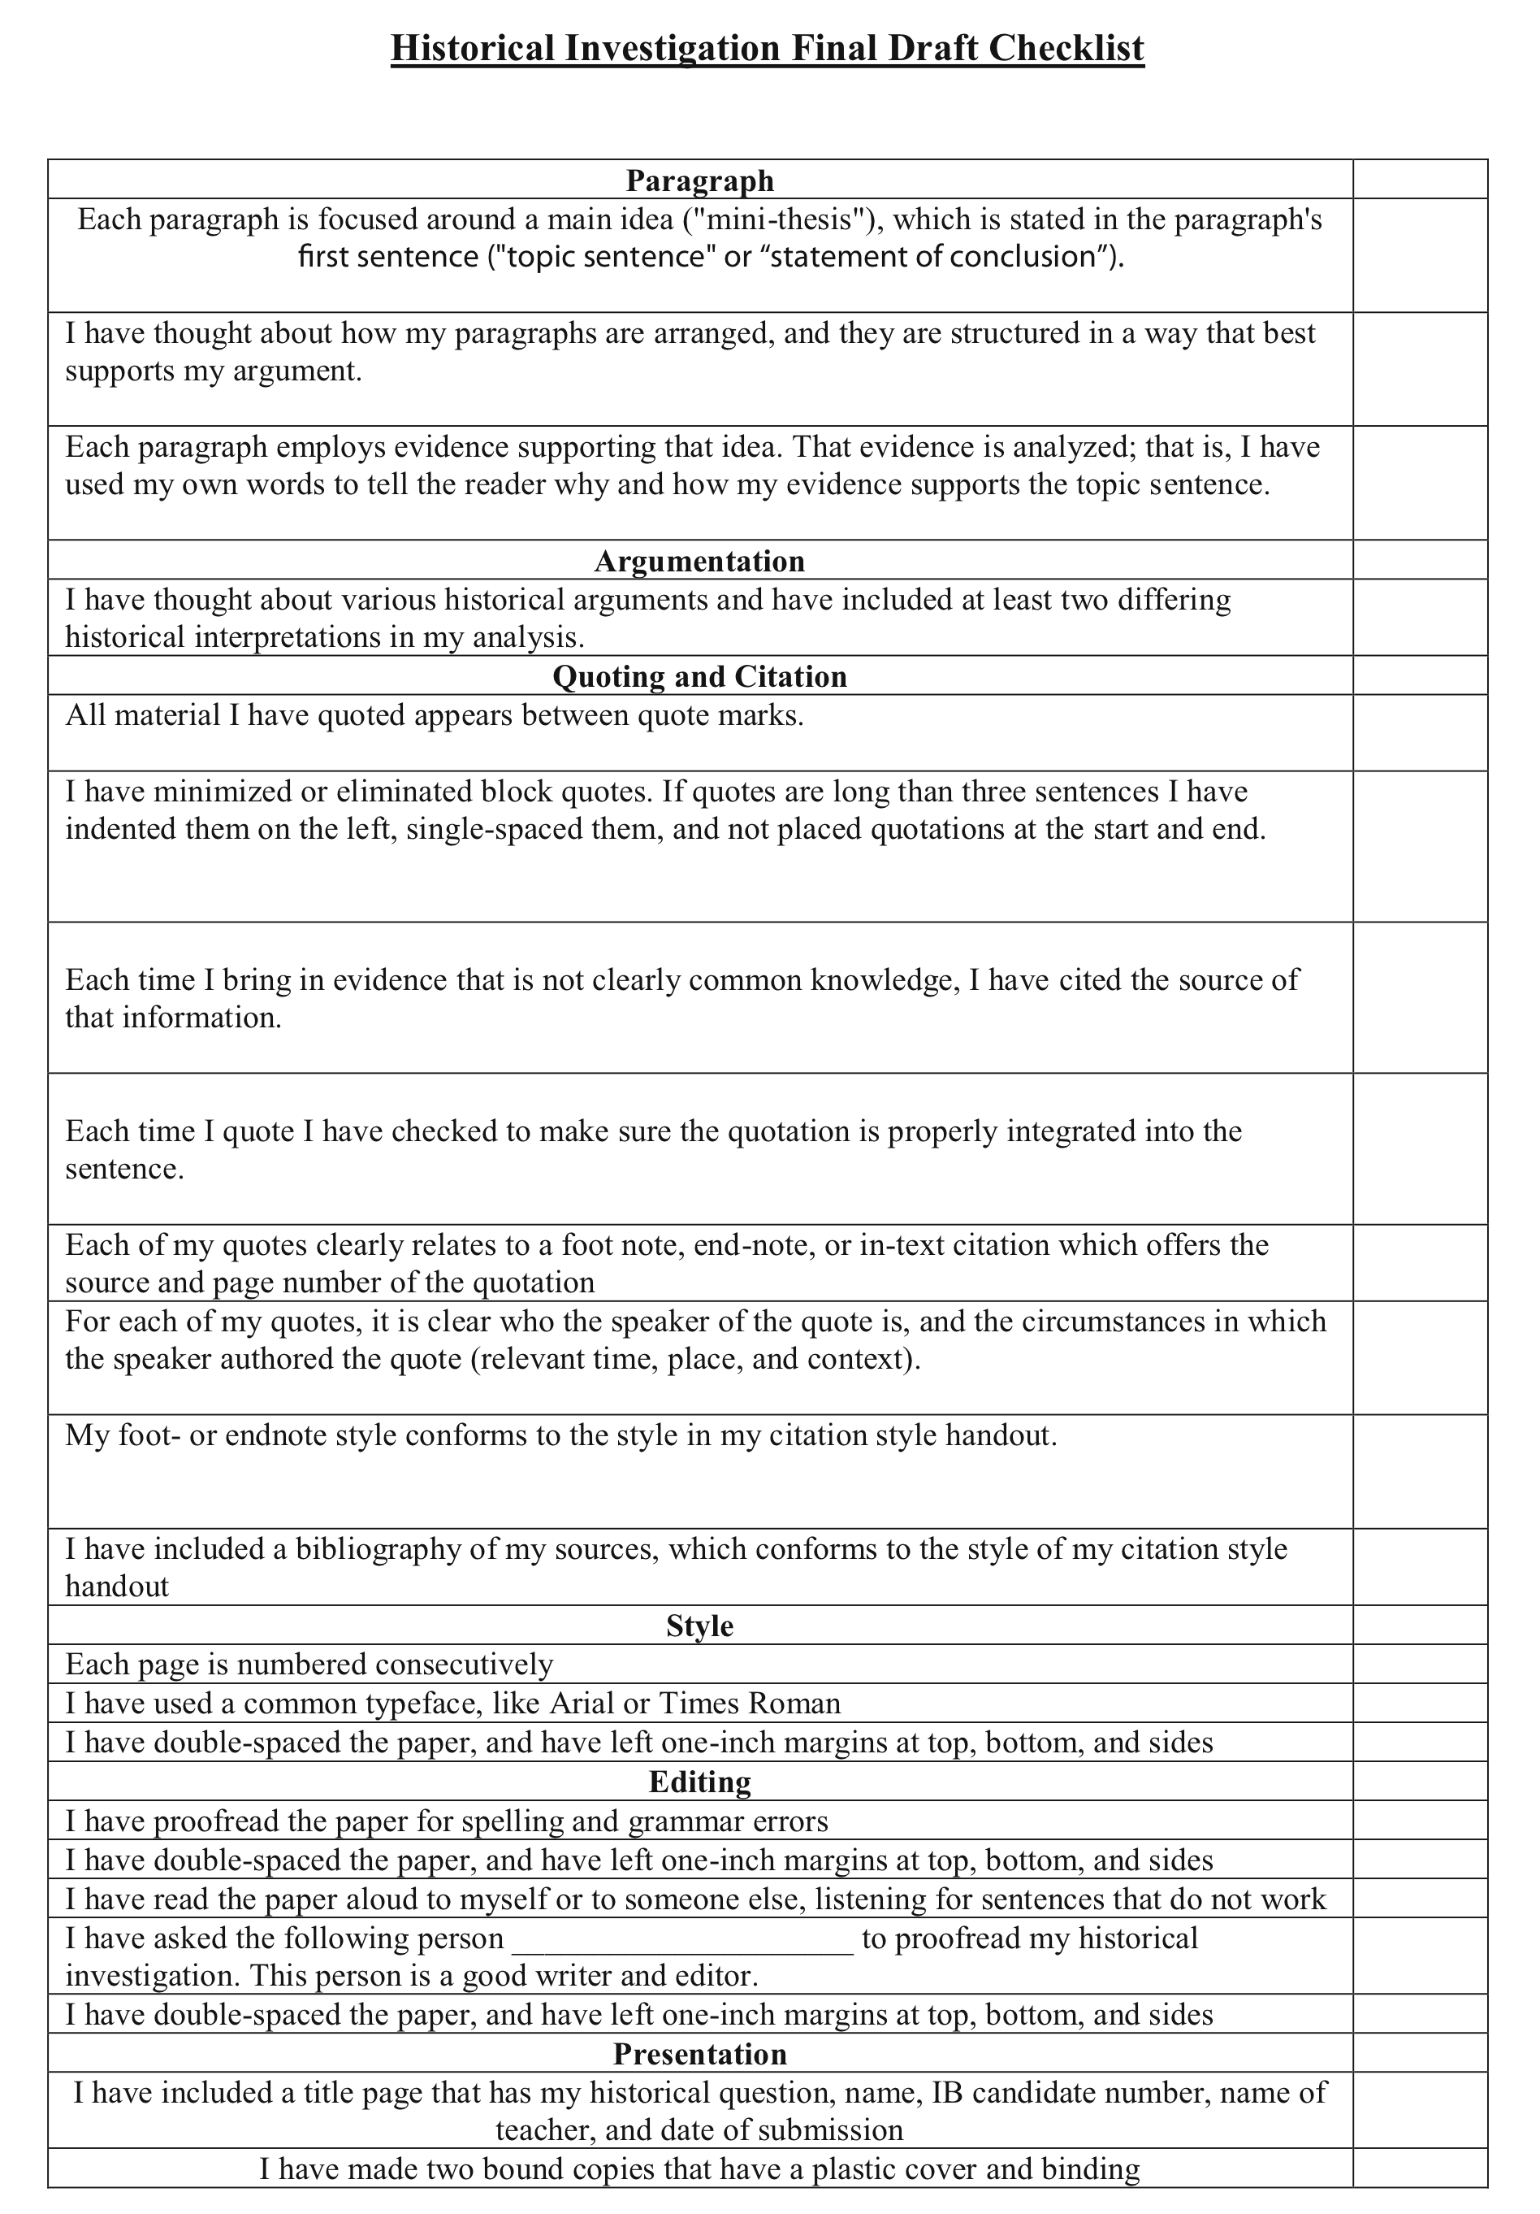

Appendix A: Assessment Criteria


